

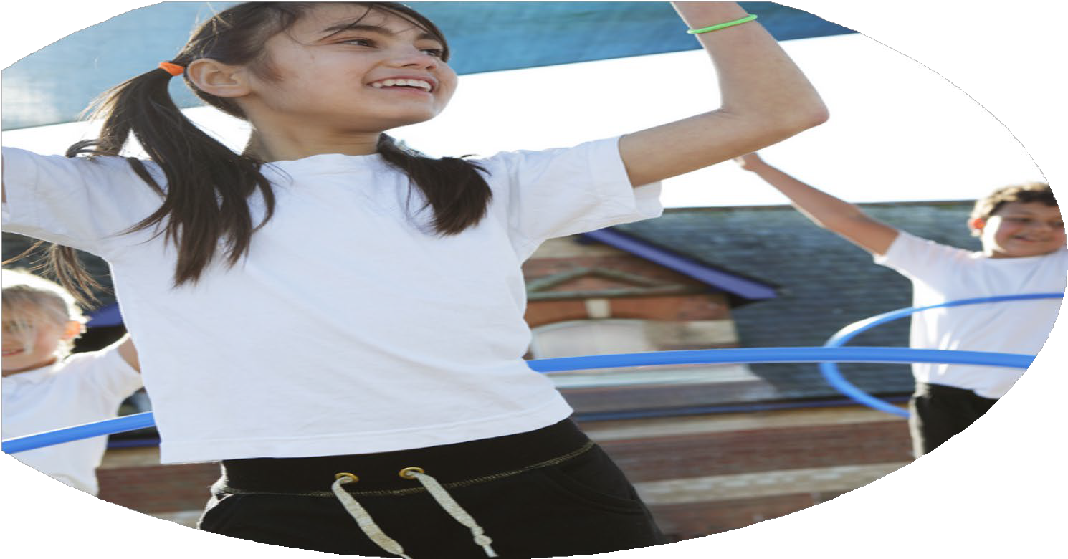
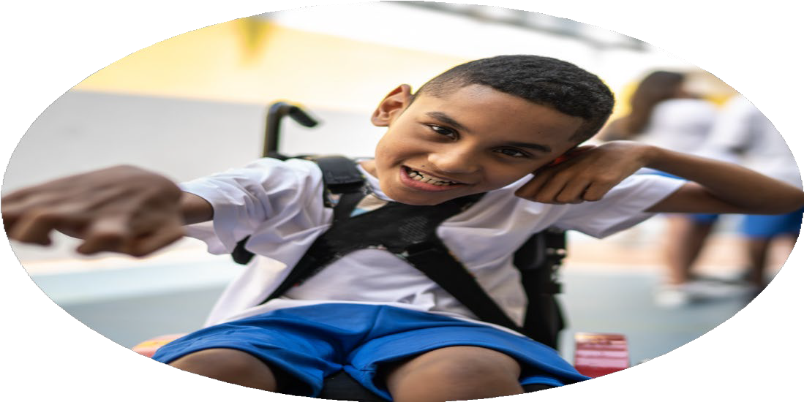




PE Funding

Evaluation Form

Commissioned by

Created by

Images courtesy of Youth Sport Trust

PE Funding Evaluation Form

It is intended that this template should be used as preparation for the completion of the statutory digital reporting tool being introduced this academic year. You can upload data (including swimming) from this template onto this platform once it becomes accessible.
Before you decide how you are going to use the funding for this academic year you should reflect and evaluate the impact of your use of the funding in 2024/25.
All spending of the funding must conform with the terms outlined in the Conditions of Grant document. The template is a working document that you can amend/update during the year.
Based on your evaluation of last year’s funding you should decide what you intend to do this academic year, how you will do it, and what impact you expect it to have.

It is important that the funding is used effectively and based on your school’s needs.
You must use the funding to make additional and sustainable improvements to the PE and sport in your school. You must develop and add to the PESSPA activities that your school already offers.

Summative digital reporting from June 2025 will continue to include swimming and water safety information therefore funding can be used to provide top-up lessons where necessary to ensure pupils meet national curriculum swimming requirements.

We recommend that you start by reflecting on the impact of current provision and reviewing your previous spend

What went well? | How do you know? | What didn’t go well? | How do you know?
PE coaching and expertise to teach games activities across the school as well as lunchtime and after-school clubs in a range of sports  Creation of new curriculum  Purchase new equipment to replace out of date, lost or broken equipment | - Increase in engagement and physical activity from all students making them more physically active  - Increase sporting performance of pupils – evidenced by competitions against other schools  - Wider range of sports being taught in curriculum  - Greater exposure to different sports for the pupils  - Increased pupil engagement in PE lessons  - Increased attendance at after-school clubs  - More equipment for lessons – meaning more opportunities to practice | Introduction of tennis coaching with qualified instructors at local tennis club | Coaches from tennis club did not ask the school this year and therefore it did not take place.

What are your plans for 2025/26? | How are you going to action and achieve these plans?
Intent | Implementation
- Increase the engagement of all pupils in regular physical activity  (£7270)  - Raise quality of teaching and learning in PE and sport by providing support to deliver a broad, balanced and inclusive high-quality PE curriculum.  (£8000)  - Provide children with opportunities for competitive sport  (£1200)  - To raise the profile of PE, School Sport and Physical Activity across the school as a tool for whole school improvement | - Purchase playground equipment  - Upgrade playground markings  - Promote the engagement of all pupils in regular physical activity  - Purchase PE specific equipment such as hurdles, balls, foam javelins.  - New storage for PE equipment  - Employ sports coaches to deliver after-school club sport  - Children to attend local tennis club to have experience of playing tennis with experienced instructors  - Local golf club to come into the school and deliver tri-golf taster session, before running school golf competition.  - Offer multi-sport lunchtime clubs run by lunch time supervisors to allow children to take part in different sports  - Bell boating in Fladbury  - Employ coaches to deliver one of the two lessons per week of PE on the curriculum - Teachers to observe when employed coaches are delivering lessons to develop subject knowledge.  - Purchase of ‘Get Set 4 PE’ scheme to support with teachers planning and delivery of PE curriculum.  - New scheme to also help improve consistency of sports on the curriculum.  - PE lead to observe teachers delivery of PE and provide feedback (generic and specific) to help improve teachers and PE curriculum.  - Purchase new equipment  - Send teachers on specific sports CPD courses ran by NGB’s to develop their confidence and subject knowledge.  - Teachers to attend seminars on outstanding Primary school provision  - Teachers to observe PE delivery in other local primary schools and partner middle/secondary schools.  - Observe coaches to develop delivery to children with SEND and adaptive teaching strategies to support them in lessons  - Purchase modified equipment to support SEND children  - Broaden the range of curriculum sports to include inclusive activities to provide opportunities for SEND.  - Register and attend local festivals and events by the SGO.  - Utilise sports coaches to organize sports day  - Transport to take children to sporting events and fixtures in the county with other schools including football, cross country and dance.  - Celebrate achievements in weekly assemblies  - Purchase sports kits for children to wear when representing the school  - Embed cross curricular opportunities within planning  - Create and maintain a PE and sports noticeboard with regular updates of children’s achievements both inside and outside of school.

What impact/intended impact/sustainability are you  expecting? | How will you know? What evidence do you have or  expect to have?
Increased uptake in activities offered at lunchtime and after-school across all sports.  More children achieving 30 minute physical activity goal.  Improved pupil understanding of the rules of different sports.  Increased confidence of lunch time supervisors to engage pupils in activities.  Less behaviour incidents during lunchtimes due to activity engagement.  Increased teacher confidence in delivering all sports included in the PE curriculum  Increased consistency in delivery of PE curriculum across staff  Reduced teacher workload  Reduction in need for external coaches  Increased attendance at local school and county events  Improved engagement from children in lessons and clubs; especially those who do not take part in sports clubs outside of school.  Introduction of new activities and clubs. | Tracking the number of children involved in the activities  Pupil voice  Observations during lunch time and after-school  Lunch time supervisor feedback  Behaviour logs  PE lead observations/learning walks  Pupil voice  Staff feedback  Staff questionnaire  Regular curriculum updates between teaching staff and PE lead  Tracking number of events attended compared to previous years  Celebration of attendance and success on school website and notice board  Club data  Target, promote and monitor key focus groups

What impact/sustainability have you seen? | What evidence do you have?
- There has been an increase in the number of children accessing after school sports clubs.  - Increased number of children participating in lunchtime multi-sport clubs which has allowed students to learn the rules of different sports, be more active and reduce behaviour incidents.  - Increased confidence in staff teaching a wider range of sports and physical activities across the PE curriculum  - Increased number of opportunities for children to participate in sport and physical activity | - Registers  - Observations during lunch time and after-school  - Lunch time supervisor feedback  - PE Lead observations  - Staff feedback  - Girls – creation of girls football lunchtime club with children from Year R to 5 attending.  - Multi-sports club – creation of additional club after-school to increase participation opportunities with children from Year R to 5 attending.

