

Church Lench CE First School
New Education Trust
Newsletter
May 22nd 2026
For With God Nothing is Impossible

ee
Dental appointments
Please could any dental appointments be booked in a school holiday or after the school day. We understand that hospital appointments and GP appointments are different, but dentist appointments can be booked in advance.
Thank you for your co-operation

Exciting Maternity News
Mrs Morgan-Lewis will be expecting a new addition to her family later this year. She will be taking maternity leave during September. We have advertised for a maternity cover teacher for Class 2 from September and will keep you up to date with this process.
I am sure you will join us in wishing her and her husband all the very best!

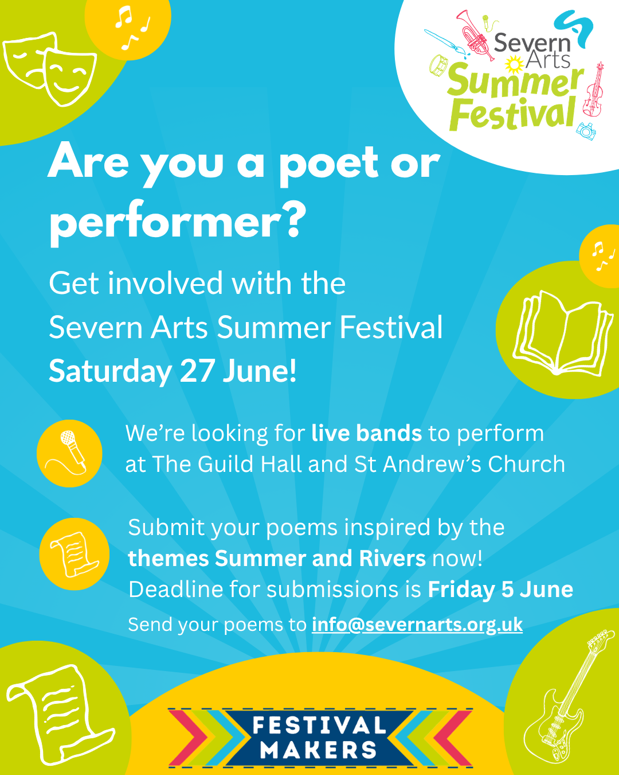

Poetry Competition for Severn arts Festival. Any child who would like to submit a poem based on rivers/ summer please email info@sevenarts.org.uk

School Fete
We are very excited to host our annual school fete organized by our wonderful Church Lench Friends committee. If you have any more donations we can take these up until Friday 5th June.

Class 1 Cake Sale
Class 1 are hosting a cake sale on Wednesday 3rd June to raise money for WaterAid. The children are hoping to raise enough money to help provide improved toilet facilities for a village in Africa.
Children are welcome to bring in a donation in exchange for a cake.

AU Sports Camps at CLFS
We have had a great uptake for next week’s sports camps hosted by AU Sports, and there are only a few spaces left to fill. If your child would like a place, please book directly with AU Sports to secure a spot.

Celebration Worship
Stars of the Week
Harry, Lottie P and Arlo
Head teacher Awards
Carolann, Freddy and Sophia
Star Maths
Ruby, Teddy A and Rose
Star Writers
Finley and Poppy
Oswald Reward
Well done to Class 2 for winning Oswald once again this week!


