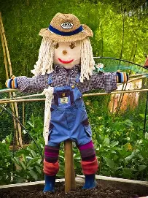
Art Day
A huge thank you to Miss Molloy for leading a highly successful art Afternoon on Tuesday, welcoming children from our local cluster schools. Pupils from St Andrew’s, Harvington, Swan Lane and Bengeworth enjoyed learning how to create a beautiful countryside landscape, working through each stage of the painting process using acrylic paints on small square canvases. Throughout the afternoon, the children demonstrated excellent focus, creativity and perseverance, producing some fantastic pieces of artwork to be proud of. The session provided a wonderful opportunity for pupils from different schools to work together, develop new artistic skills and share their enthusiasm for art. The afternoon was thoroughly enjoyed by everyone involved – including the adults! Thank you again to Miss Molloy for inspiring the children and making the event such a memorable experience.
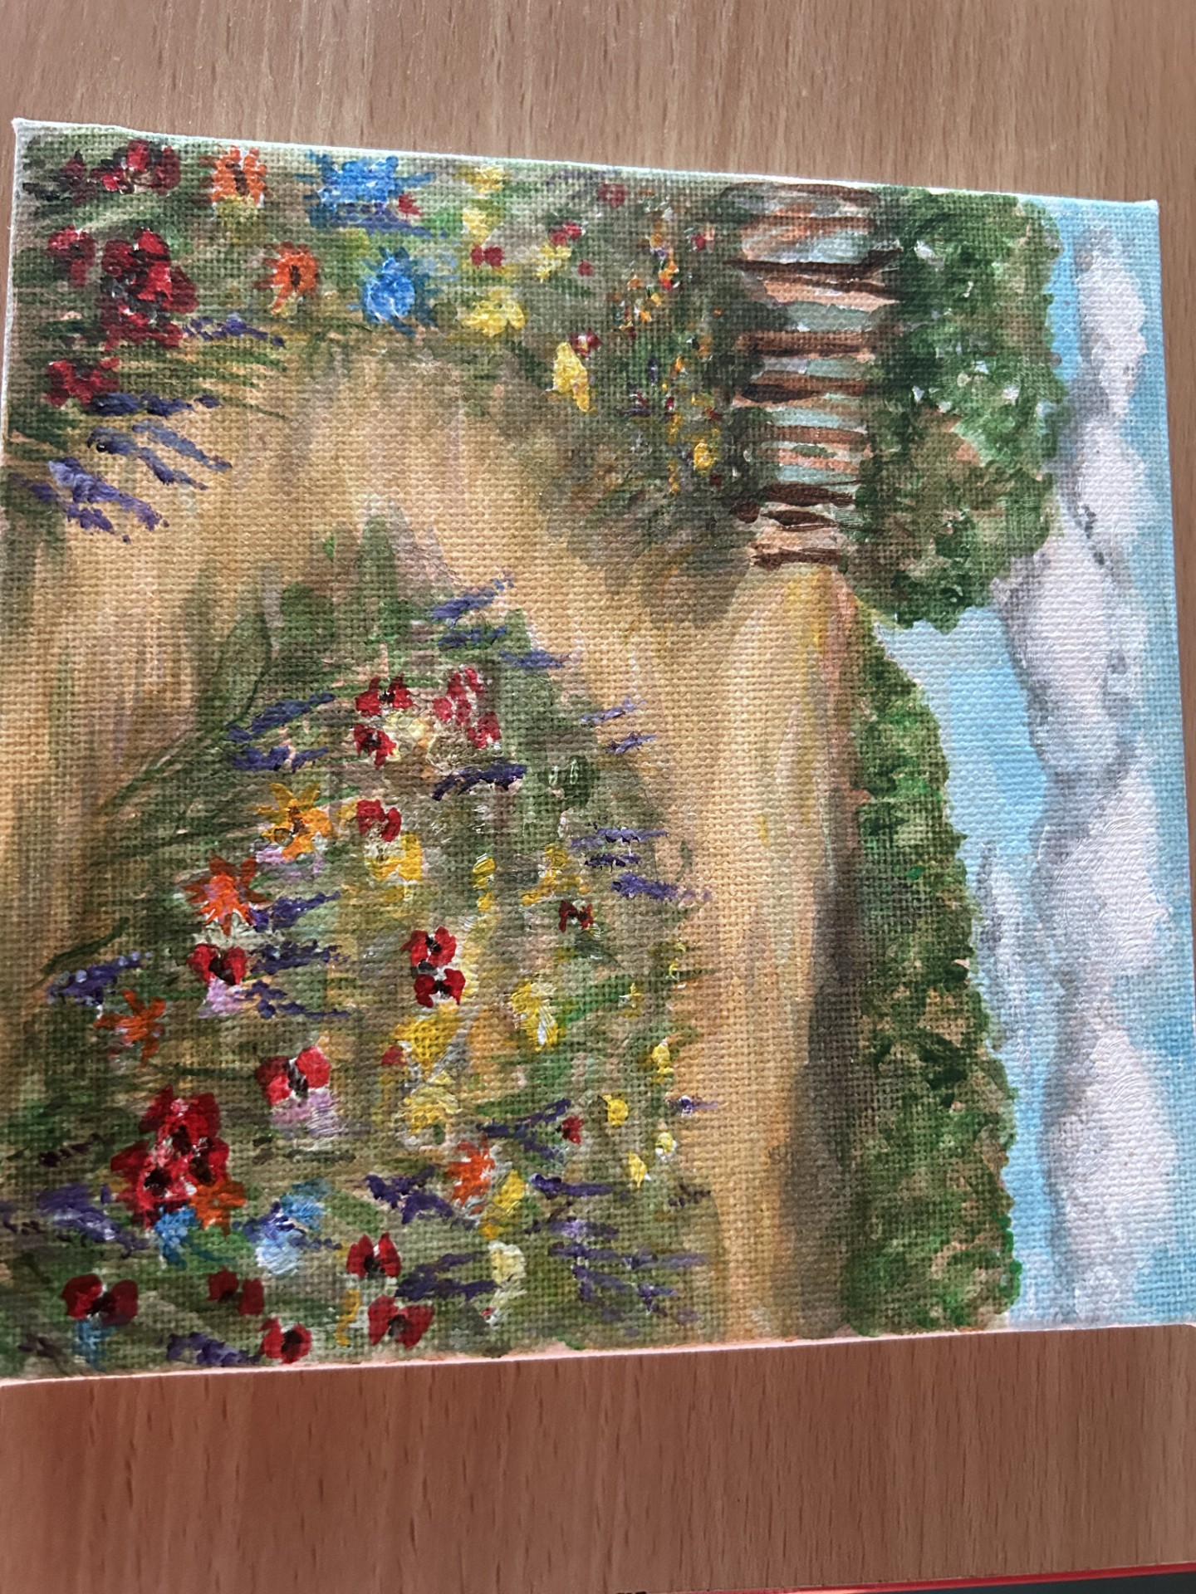

Church Lench CE First School
New Education Trust
Newsletter
June 26th 2026
For With God Nothing is Impossible

ee
SIAMS Inspection
Statutory Inspection for Anglican and Methodist Schools
Yesterday we had our five-yearly SIAMS inspection, which we look forward to sharing with you as soon as we receive the report. In the meantime, I wanted to say how incredibly proud we all are of our children. They spoke so positively, thoughtfully and maturely to the inspector, and were wonderful ambassadors for our school. They should all be very proud of themselves.

Messy Church
Sunday 28th June
Harvington Village Hall
330-530pm
Our theme is "Shipwreck" focussing on St Paul's shipwreck in Malta
Finishing with a full 2-course meal
All free and all welcome

Celebration Worship
Stars of the Week
Albert, Elodie and Liv
Head teacher Awards
Vinnie, Nathan and Arlo
Star Writers
Pixie
Star Maths
Luke and Missy
Kindness Bear
Flo and Natalie
Oswald Reward
Well done to Class 3 who won Oswald this week!

Church Lench Flower Festival
The annual village flower festival is taking place this weekend around Church Lench with a concert starting tonight in church. Look out for Queen Victoria outside the school!
Dates Coming Up:
Class 1 trip to Top Barn Farm 1st July
Parent book Look 2nd July 2.45pm
End of Year Reports to parents 3rd July
Rock Steady Concert 6th July 2.30pm
New Parent meeting 6th July 6pm
Class 2 trip Redpoint Climbing Centre 7th July
Sports Day 8th July
Leavers Service 16th July 2.30pm
Father Glenn to give out Bibles in school 17th July
Leavers Lunch 17th July 12.15pm

Transition Day
We were delighted to welcome our new reception children on Wednesday as they began their journey with us. Our Year 5 pupils also enjoyed spending time at their new middle schools, taking an exciting step towards the next stage of their education. Meanwhile, all of our other pupils made a successful transition into their new year groups. It was wonderful to see them settle so quickly and embrace the opportunities ahead with enthusiasm.

