

Church Lench CE First School
New Education Trust
Newsletter
November 7th 2025
For With God Nothing is Impossible

ee
Eco Committee
We have our new eco committee for this year who will start working on our carbon net zero action plan.
Congratulations to our new committee members and their great application forms:
Grace (Class 1) Lottie P, Lottie C (Class 2) Sam and Joel (Class 3)
They will be working closely with Ms Munro in the coming weeks!

Movember
In conjunction with the Head Boy and Head Girl, Mr Enstone has agreed to take part in Movember this month. Henry and Penny have decided that any donations will go to the charity 'MND Association'. Each Friday there will be a collection box in the library should you wish to donate and obviously you will be able to keep an eye on Mr Enstone's moustache on the school gate!




Remembrance Merchandise
We will continue to sell poppy merchandise next Monday and Tuesday. On Tuesday morning, we will hold a minute’s silence on the playground to remember all those affected by war.
Throughout the week, all classes will be learning about the importance of remembrance and why we mark this occasion.

Cookery Club
Debbie starts her cookery club on Monday afternoon. We have eight children from class 3 who will be learning how to cook a variety of foods this half term. They start with making homemade meatballs and sauce!


After School Club
Theme Nights
Our LEGO Theme Night was a huge hit!
All the children had a fantastic time building some amazing creations with our new LEGO kits. If you have any good-quality LEGO sets (with instructions) that you’d like to donate, we’d be very grateful — they’ll help us keep the creativity going!
T4U
Thank you so much for your shoebox donations! We have had an amazing response and collected many boxes for vulnerable children in Romania. We will be asking for all boxes to be dropped off by next Tuesday 11th November.

Firework Lunch!
A huge thank you to Debbie for providing a fabulous firework-themed lunch on Wednesday! The children thoroughly enjoyed it, and we really appreciate all your hard work in making the meal such a fun and exciting experience.
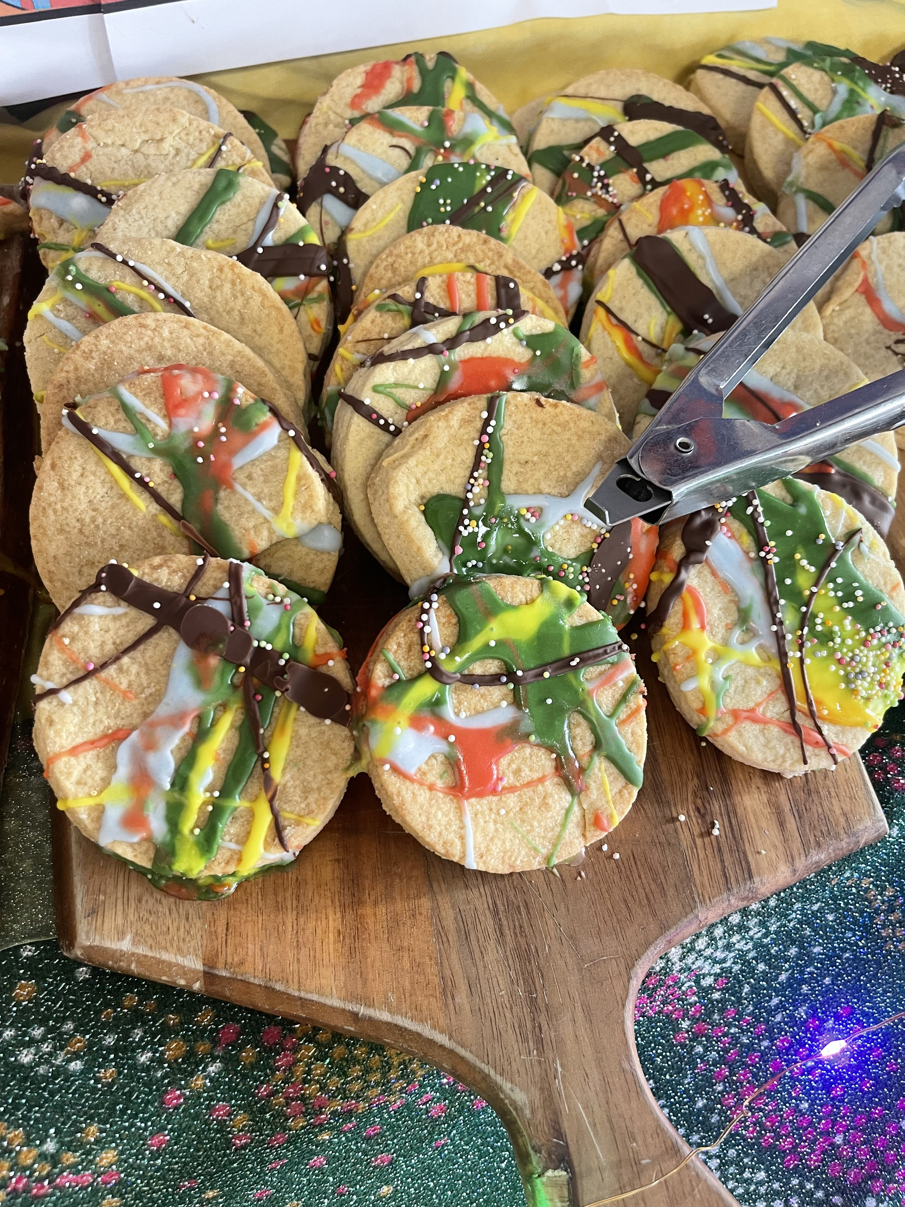

Parent questionnaire
We will be sending out our annual Parent Questionnaire next week. Please could you take a few minutes to complete it and return it by the end of November — plenty of time!
We really value your feedback and are always keen to hear your thoughts on how we can continue to improve.
Thank you for your support.

