
Senior Games Afternoon
We had an absolutely fantastic day yesterday hosting our Games Afternoon! We were delighted to welcome senior residents from our community to join us for a variety of board games and puzzles. The atmosphere was warm and lively, and it was wonderful to see everyone enjoying themselves.
Our children were a real credit to the school—showing impeccable manners, confidence, and enthusiasm as they engaged in conversation with our guests.
Games on offer included Operation, Chess, Old Maid, Draughts, Shut the Box, Snakes and Ladders, Connect Four, and Battleships.
We’re already looking forward to hosting this event again in the spring or summer term!

Church Lench CE First School
New Education Trust
Newsletter
November 21st 2025
For With God Nothing is Impossible

ee
Teddy Bear Day Class 1
Class 1 are having Teddy Bear Day on Monday 24th November. Please remember to send your child in with a teddy bear!

Celebration Assembly
Stars of the Week
Teddy T, Natalie and Molly
Head Teacher Awards
Sophia, Alfie S and Darcy
Star Writers
Daisy
Star Mathematicians
Jobey, Henri and Elodie
Oswald Reading Reward
Well done to Class 2 for winning Oswald this week. Come on Class 1!!!

Parent Questionnaire
Thank you for the returned questionnaires so far! It has been lovely to receive such positive feedback. Please could these be returned by Friday November 28th
Thank you

Thank you so much for all your kind donations. We managed to send ….boxes 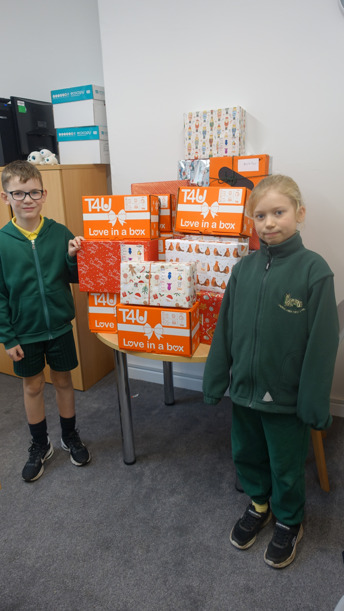

Comfy Clothes Day!
Our Friends of Church Lench are delighted to share that Comfy Clothes Day will take place on Thursday, 27th November. This is in return for an item for our Christmas Hampers once again this year. A raffle will be held following the Church Christmas Service on Thursday, 18th December and one lucky family from each class will receive a Christmas hamper.

Spirituality Workshops
On Wednesday, we were pleased to welcome Reverend Duncan Hutchinson from the Worcester Diocese, who led spirituality workshops for each class. It was an uplifting and reflective morning, giving pupils the opportunity to take part in activities that helped them feel more connected to one another and to the wider world.


Governor Monitoring Visits
This week we have had two governor monitoring visits taking place to ensure that we are carrying out our school development priorities. Both visits were very positive focusing on multiplication and writing. We will share the reports in due course.
DVDs
If you have any children’s ‘U’ rated DVDs you would like to donate we would love a few more for our breakfast and after school club sessions.
Parent/ Carer Book Look
Parents and carers are welcome to come in from 2.45pm-3.20pm and 3.25pm-4.15pm on Thursday 27th November to look at their child’s books.

