
Parent/ Carer Book Look
It was lovely to welcome so many parents/ carers to our book look session yesterday to come and look at workbooks. Our next book look takes place on Thursday 12th February.

Church Lench CE First School
New Education Trust
Newsletter
November 28th 2025
For With God Nothing is Impossible

ee
Christmas Service
Our Christmas service will be held on Thursday 18th December at 9.30 a.m. in the church. Following the service, we warmly invite you to join us in the hall for refreshments. Our Christmas hamper raffle will also be drawn.


Comfy Clothes Day
Thank you for all the raffle gifts you kindly donated! Our Friends committee will be very busy preparing the hampers for 18th December! We had some lovely donations.

Thank you so much for all your kind donations. We managed to send ….boxes 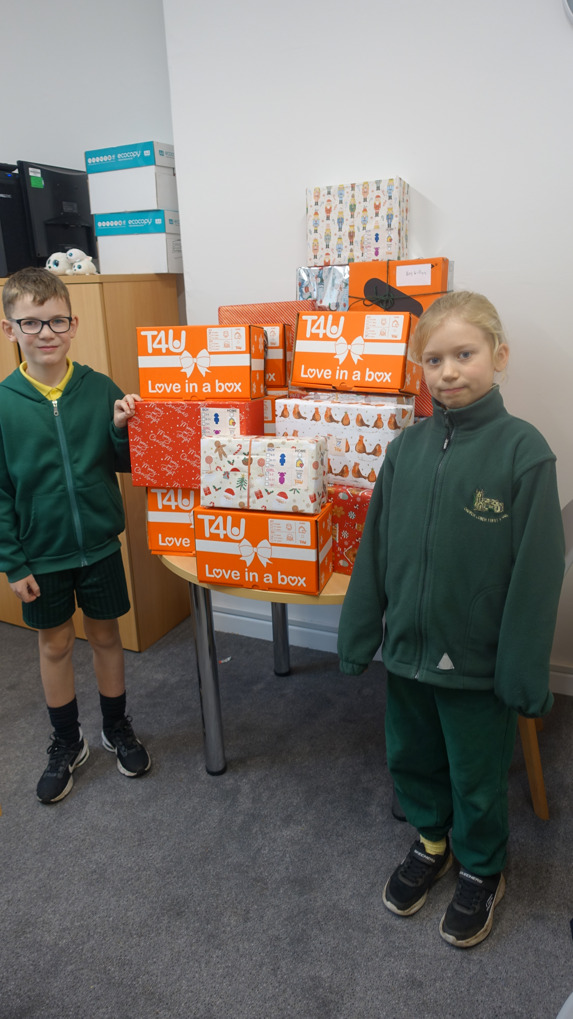

Celebration Assembly
Star of the Week
Poppy, Pixie and Greg
Head Teacher Awards
Jacob, Ruby W and Nathan
Star Writers
Sammy, Bertie and Amelie
Star Mathematicians
Sammy, Henry B and Natalie
Kindness Bear
Nathan
Oswald Reading Reward
Well done to Class 3 achieving 100% of the class reading 4 or more times a week!

School Disco
The Friends of CLFS are planning and organising an end of term winter disco. A flyer has been attached with the newsletter and payment can be made on Arbor. All snacks and sweets are included in the price so children do not need to bring extra pennies.


Parent/ Carer Questionnaire
Thank you for all the forms we have received so far please could any outstanding ones be returned by Monday.
Christmas Choir
Please see attached flyer with the newsletter

Cookery Club
Class 2
A letter has been sent with information for children in class 2 to sign up to cookery club in January. The children in class 3 have really enjoyed the experience!

Messy Church
Sunday 30th November. Harvington Village Hall
3.30-5.30pm
No charge. All welcome

