
Advent
Our school altar cloth has now changed to purple, symbolising this special time of preparation and reflection as we journey toward Christmas. The church is also displaying the Advent wreath, reminding us of the hope, peace, joy, and love we anticipate during this season.

Church Lench CE First School
New Education Trust
Newsletter
December 5th 2025
For With God Nothing is Impossible

ee
Christmas Service
Our Christmas service will take place on Thursday 18th December at 9:30 a.m. in church.
Apologies that this date was not shown on our website calendar. It appears that some information didn’t transfer during the recent website migration, and we’ve experienced a few issues as a result. Thank you for your understanding.

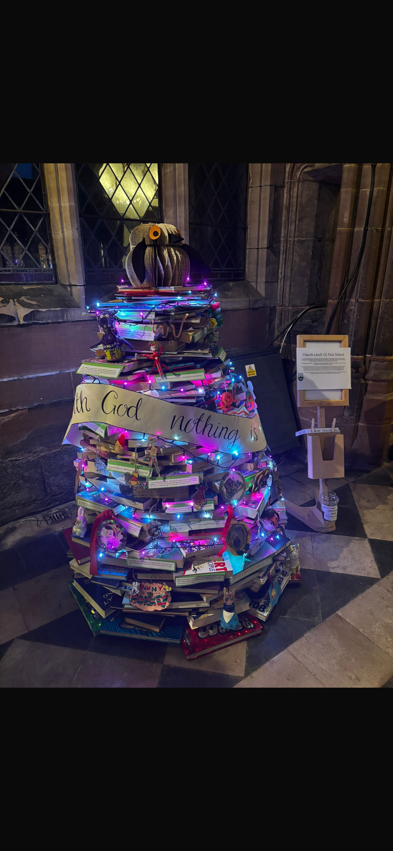
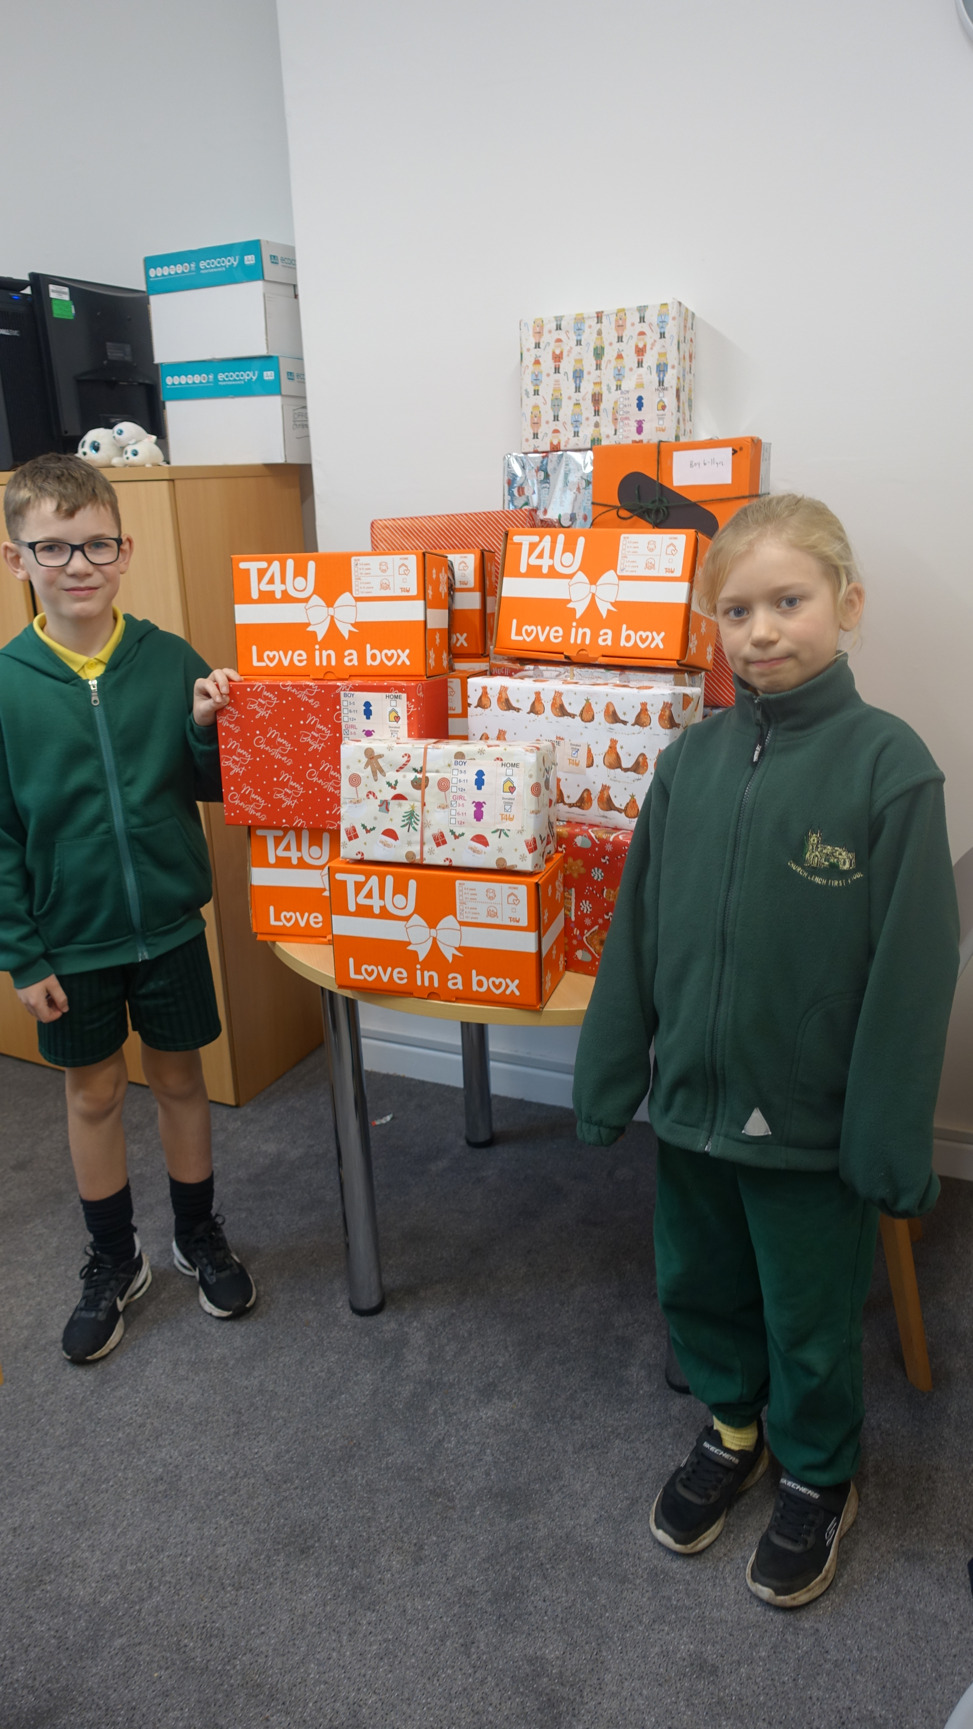

Worcester Cathedral
School Christmas Tree
If you visit Worcester over the Christmas period our wonderful tree made from books can be seen outside the café in the cloisters!
A huge thank you to Ms Munro for planning and organising the creation this year. Ms Munro and Mrs Morgan Lewis did a sterling job of constructing it on Tuesday evening.
Celebration Assembly
Stars of the Week
Ellie and Martha
Head Teacher Awards
Elodie and Finley
Star Writers
Alfie S
Star Mathematicians
Emily
Kindness Bear
Jobey
Oswald Reading Reward
Class 1 have won Oswald this week with the majority of children reading 4 or more times a week! Keep up the great work

Christmas Dates
Thursday 11th December School Disco 4-5.30pm
(Children can change at school then go straight to the hall. Reception parents welcome to stay)
Monday 15th December Rock Steady Concert 2.30pm
Tuesday 16th December Choir singing at Willow bank Dementia Care Home 2pm
Wednesday 17th December Pantomime in school
Wednesday 17th December Christmas lunch
Thursday 18th December Christmas service in church 9.30a.m with refreshments and raffle in hall afterwards
Thursday 18th December Christmas Movie Night
Friday 19th December Christmas Jumper Day and a visit from FC!

Cooking Club – Class 2
We still have spaces available for Class 2 children to join our Cookery Club after Christmas. This half term, Class 3 pupils have absolutely loved working with Debbie to make a variety of delicious foods, and we’re excited to offer the same fun experience to Class 2!

Parent Questionnaire Feedback
We are once again delighted with the feedback from our recent parent questionnaire. We received responses from 89% of our families, which is fantastic. The results have been attached for you to review alongside this newsletter. Thank you so much for taking the time to fill it in, it is much appreciated.

