
Christmas Jumpers
Children may wear Christmas jumpers or a festive Christmas outfit on Friday 19th December.
In addition, children in Classes 2 and 3 are asked to wear a Christmas jumper on Thursday 18th December for our church service.

Church Lench CE First School
New Education Trust
Newsletter
December 12th 2025
For With God Nothing is Impossible

ee
Parking Consideration and Safety
Please remember to park considerately outside the school. There are still cars parking on the bend and, at times, on the pavement, which poses a danger to pedestrians and other road users. The zig-zag areas should also be avoided unless you have permission from the school. The Tuer also needs to kept clear as there are cars that need to access this road on a regular basis.
There is plenty of parking available at The Lenches Club. Thank you in advance for your cooperation.

Movie Night
Next Thursday we have our school movie night. We will be showing ‘That Christmas’ with refreshments.

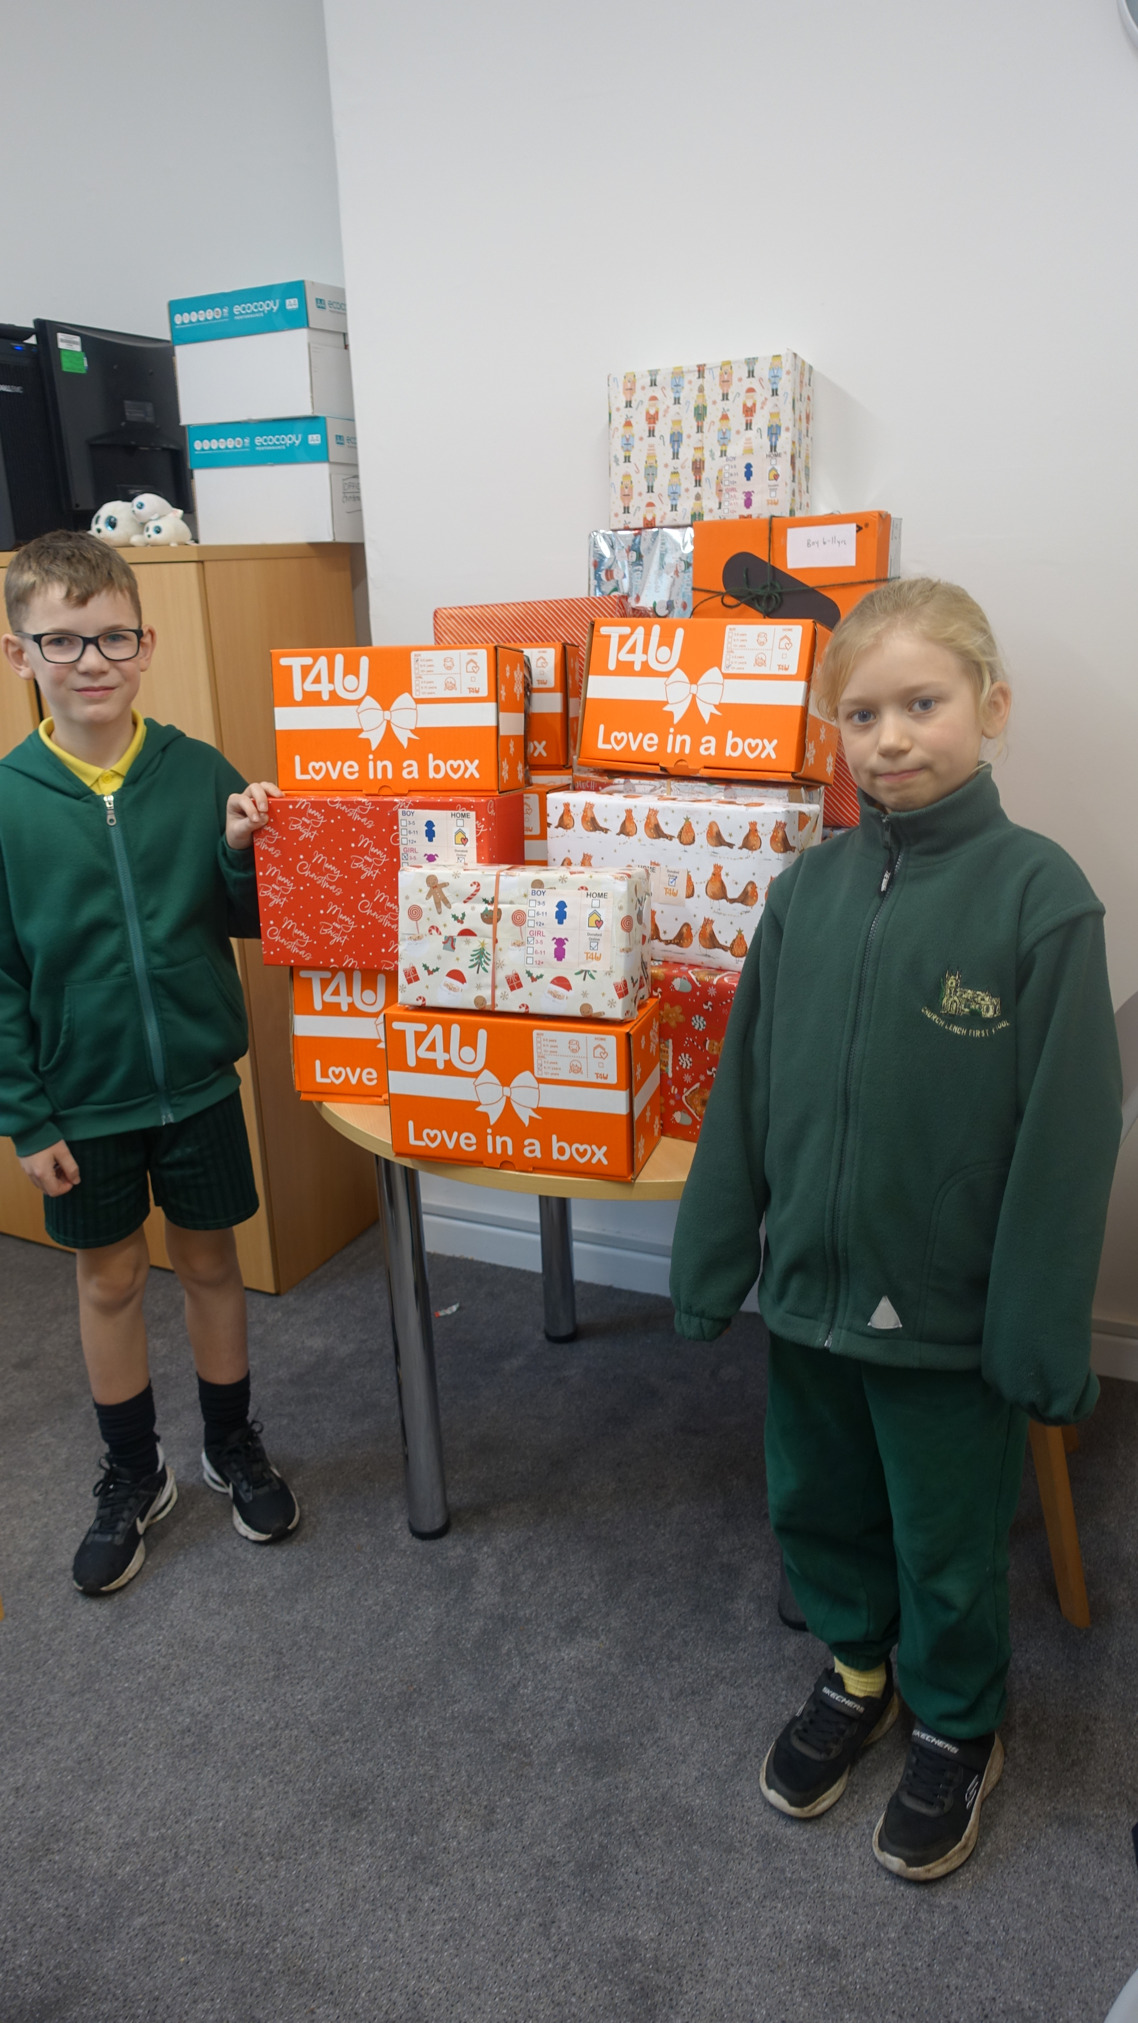

Celebration Assembly
Stars of the Week
Rosie, Henry P and Grace C
Head Teacher Awards
Teddy A, Elliot and Freddie
Star Writers
Penny, Gracie and Missy
Star Mathematicians
Daisy, Jacob, Joel, Rhianna and Lottie P
Kindness Bear
Teddy A
Oswald Reading Reward
Class 2 have won Oswald this week with the majority of children reading 4 or more times a week!

Nut Free School
Please ensure that no food containing nuts is sent in packed lunch boxes. We are a nut-free school and, although we do not currently have any pupils with nut allergies, we continue to promote a nut-free environment for the safety and well-being of all children.

Choir
Our choir will be visiting Willow Bank dementia Care Home next Thursday to sings some carols. Thank you to Ms Munro for organising the event.

Disco
Our disco was a huge success last night! The children had an amazing time and impressed us all with their fantastic dance moves.
A huge thank-you to our wonderful Friends Committee for organising such a brilliant event.
All funds raised will go towards supporting school resources and trips, which is always greatly appreciated.

Celebration Assembly
There will be no celebration assembly next Friday. Our next one will take place on Friday January 9th
Father Christmas
We have been told that Father Christmas will be visiting us next Friday! He has found some time out of his busy schedule to pop in and say hello to us all!

Royal British Legion
We are very proud to announce that the school raised an amazing amount of £210.23 for the Royal British Legion. Thank you all for your support.

