
Parking Consideration
We have been monitoring the parking outside school, as we have received complaints from nearby residents regarding blocked roads and restricted access. Please ensure you arrive in plenty of time to park at the Lenches Club and walk to school, so that access is always kept clear and the zig-zag lines outside school remain unobstructed.
Thank you for your cooperation.

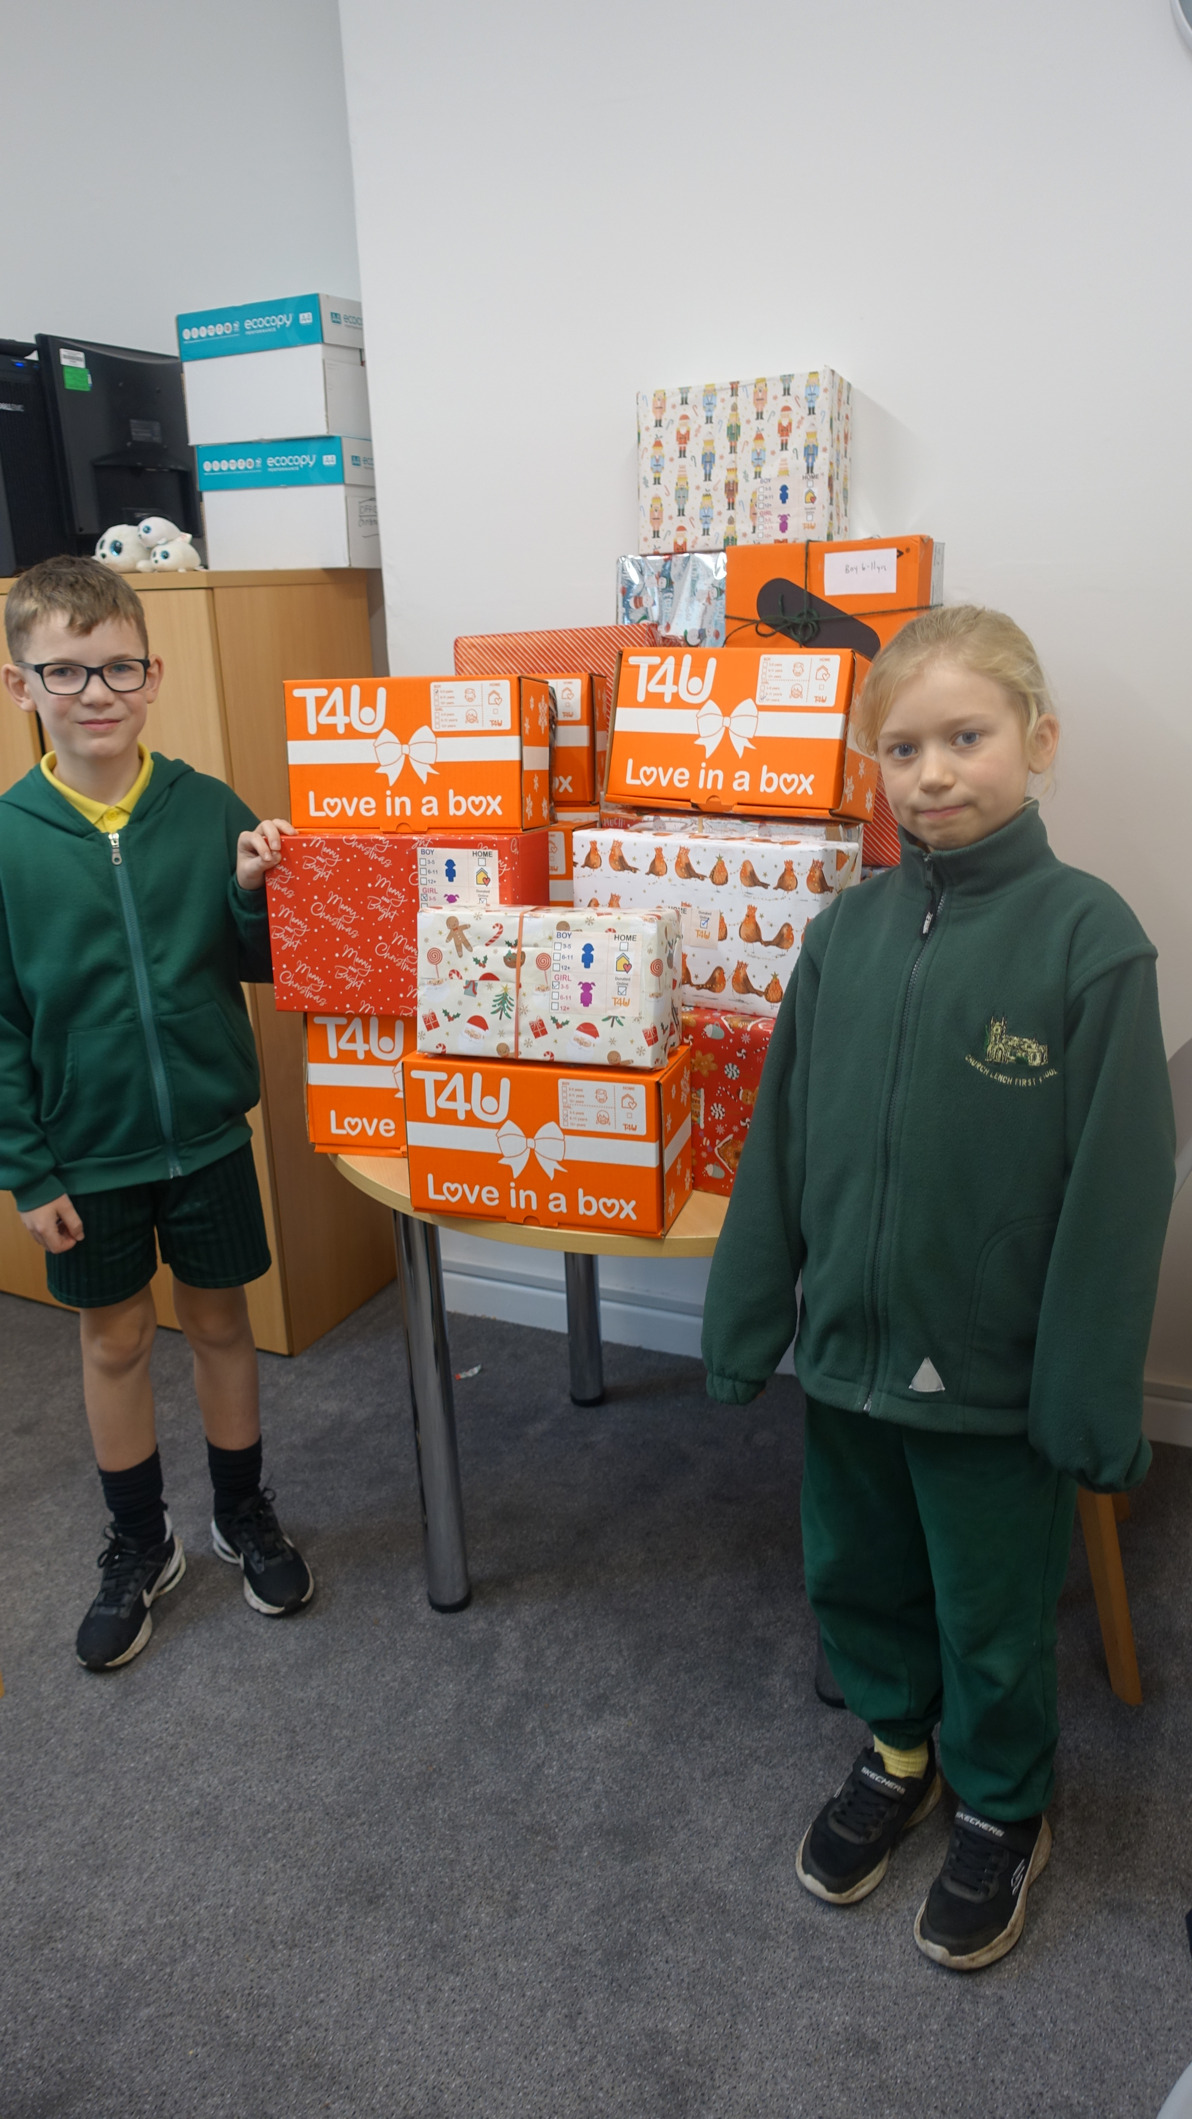

Church Lench CE First School
New Education Trust
Newsletter
January 16th 2026
For With God Nothing is Impossible

ee
Cross Country
Good luck to Florence and Miriam who will be taking part in the district cross country final on Monday!

New Children’s Commissioner Report
‘What I Wish My Parents and Carers Knew- A Guide for Parents on Managing Children’s Digital lives’

This is an excellent article written for parents and carers about managing the digital world we live in. I would highly recommend you having a look at this to support your children with technology.

https://www.childrenscommissioner.gov.uk/resource/what-i-wish-my-parents-or-carers-knew-a-guide-for-parents-and-carers-on-managing-childrens-digital-lives/

Reading Expectations
We expect all children to read at home at least four times a week and for their reading diary to be signed by an adult. Last term, Class 2 won Oswald the most times, so it would be great to see Classes 1 and 3 giving them some strong competition this term!

Visit from Chris Bloore MP
We were delighted to welcome our local MP, Chris Bloore, to our caring, small village school. During his visit, Chris spent time talking with staff, pupils and myself about issues and concerns important to our community. He listened carefully and made a note of the key areas he will raise in Parliament:
Road safety: Concerns were raised about the speed of vehicles travelling through our village and how measures such as speed cameras or speed bumps could help slow traffic and keep everyone safe.
Facilities for children: Church Lench would benefit from more facilities for children beyond the local park — a trampoline park was even suggested!
Inclusive communication: The idea of introducing basic sign language into the school curriculum was discussed, so everyone can develop an understanding of how to communicate with people who have hearing or communication challenges.
Chris thoroughly enjoyed his visit and commented on what a lovely school we have. He engaged enthusiastically with the children and took the time to listen to everything they had to say.


Treasurer Role
We are currently looking to fill the role of Treasurer for our Church Lench Friends Committee. We have a fantastic team of dedicated volunteers, but we are in urgent need of a treasurer to help manage and keep track of the committee’s funds. If you are interested in taking on this important role, please contact the school or speak to Justine Willis, the chair.
Your support would make a real difference — thank you!

Celebration Assembly
Stars of the Week
Lucia, Lottie P and Jacob
Headteacher Awards
Grace and Nelly
Star Maths
Freddy, Rose, Henry P
Oswald Reading Award
We are super proud of our Class 1 pupils who won Oswald this week, with 100% of the class reading 4 or more times in the week!!!

