
Usborne Sponsored Read
We are hoping for a great response for our sponsored read this year. The children were all very excited to hear that we will be purchasing new titles for the library!
Thank you for your support in advance. We look forward to receiving sponsorship donations in the next couple of weeks.
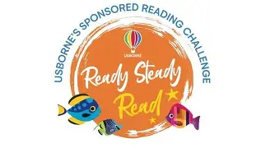

Church Lench CE First School
New Education Trust
Newsletter
March 6th 2026
For With God Nothing is Impossible

ee
Author Visit
Gillian Young
Yesterday we were delighted to welcome author Gillian Young, who visited us with her best friend, Poppy the golden retriever.
Gillian spent time with every class reading exciting extracts from her Crazy Cream Adventure series. The children loved hearing about the adventures in her books — especially as Poppy herself is the inspiration behind many of the stories!
Gillian also shared how she dreamed of becoming an author and began writing stories when she was young. Her message to the children was clear: if you love stories and use your imagination, you can create amazing adventures too.
Of course, Poppy was the star of the show, charming everyone and showing us why she’s such an important part of the Crazy Cream Adventure books. She certainly looks like a dog who loves an adventure!
A huge thank you to Gillian and Poppy for such an inspiring visit.
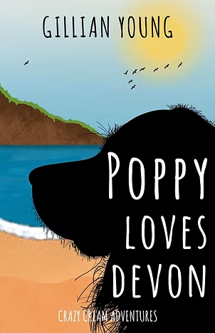

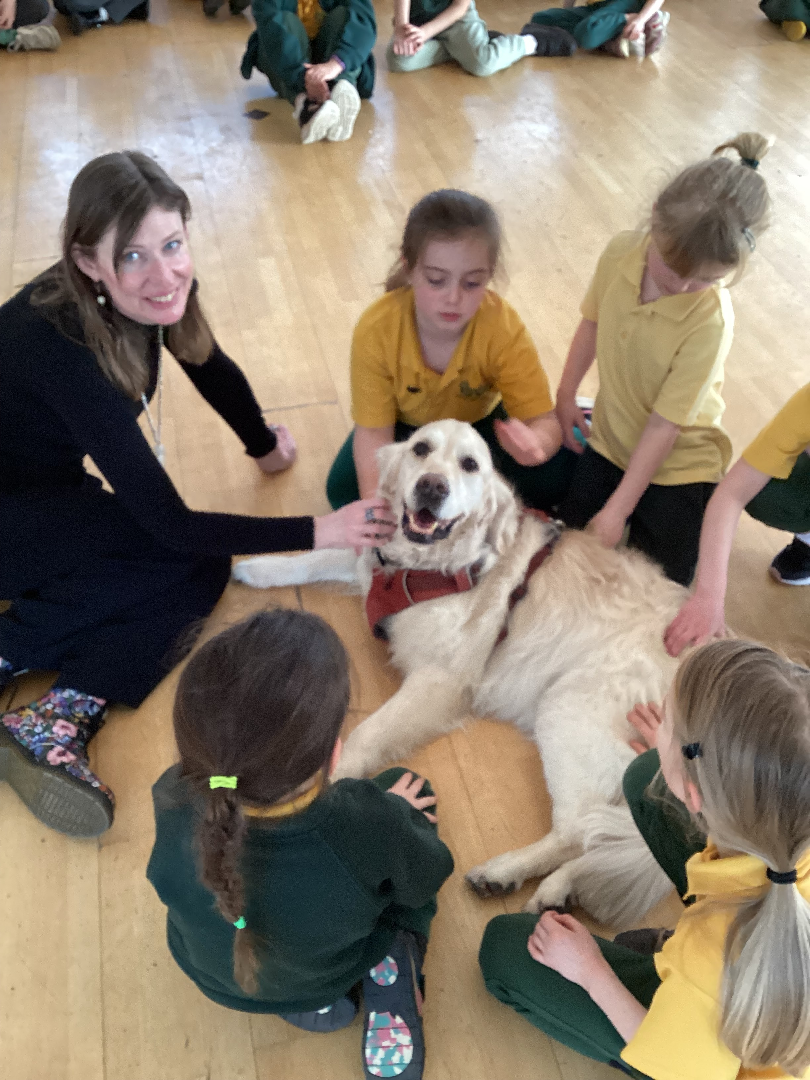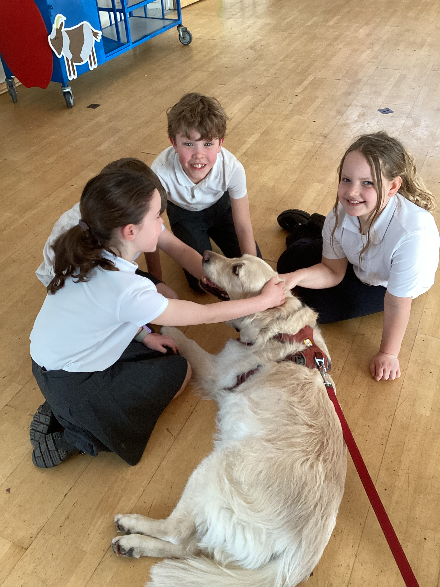
Poppy loving a big fuss with her fans!

Non-Uniform Day
On Friday 13th March we have a non-uniform day in support of our summer school fete. Please see the attached flyer with this newsletter from our Church Lench Friends.

Teacher/ Parent Consultations
Our spring consultations take place on the 16th and 19th March online from 3.30-6.30pm
Bookings now open
https://churchlenchcefirst.schoolcloud.co.uk/

Celebration Assembly
Stars of the Week
Annie, Millie and Henry B
Headteacher Awards
Henry B, Lottie C and Harry
Star Maths
Ellie, Vinnie and Poppy
Star Writers
Teddy A
Kindness Bear
Alfie S
Oswald Reading Award
Well done to Class 3 this week for winning Oswald once again!! Come on classes 1 and 2.

Reading in Celebration Worship
Well done to Martha in Class 1, who shared some wonderful reading with us during Celebration Worship this morning. She confidently and clearly read an extract from one of her favourite books, The Famous Five. We love hearing about the children’s favourite stories and celebrating their reading. If your child would like to share a short extract from a book they enjoy, please let us know — we would be delighted to hear them read on a Friday morning!

