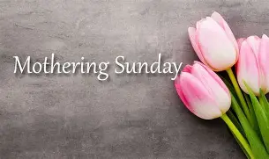
Usborne Sponsored Read
Please could all forms and donations come in by Friday 20th March. We have had some very generous donations already so thank you very much!
We really hope we can purchase a variety of new books for our library.


Church Lench CE First School
New Education Trust
Newsletter
March 13th 2026
For With God Nothing is Impossible

ee
Cross Country Success
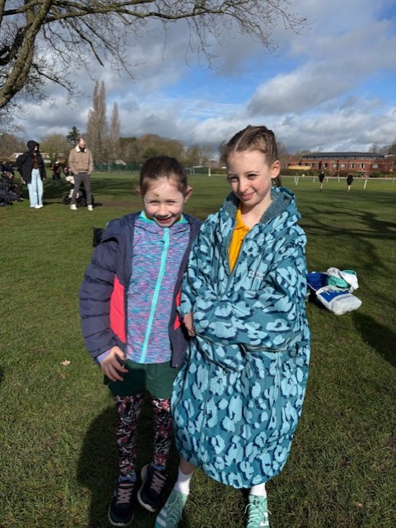
Well done to our two amazing Year 5 runners during the cross country county trials this week at Bromsgrove School! The girls showed amazing resilience and ran a fantastic race. We look forward to finding out about the national trials next weekend.

Teacher/ Parent Consultations
Our spring consultations take place next week on 16th and 19th March online from 3.30-6.30pm
Bookings close on the 19th March. We cannot arrange a different time if you do not book your consultation due to other commitments at this time of year.
https://churchlenchcefirst.schoolcloud.co.uk/

Celebration Assembly
Stars of the Week
Oliver, Bertie and Greg
Headteacher Awards
Florence, Miriam, Henry P and Alfie M
Star Maths
Sophia, Natalie and Danae
Star Writers
Florence, Lottie C, Elliot, Ruby, Brookie,
Henri and Rosie G
Kindness Bear
Natalie


Happy Mothering Sunday to all of the mums out there! Have a lovely weekend

Reading in Celebration Worship
We would still like to hear from any children who would like to share an extract from their favourite book during celebration worship. Please let your child’s teacher know if this is something they would be confident to share.

Class 1 Superhero Day
To celebrate the end of term and to complete our superhero topic, we will be having a Superhero Fun Day on Friday 27th March, where children can come dressed as a superhero, if they would like to! The superhero can be a real-life superhero (such as a vet, police officer, farmer, nurse, dentist....) or pretend (no weapons please). They will spend the day being superheroes, taking part in lots of fun activities that will promote their superhero skills. We look forward to a great last day of term!
If you would like to borrow a costume, please just let us know as we have a variety of outfits for the children to choose from.


